**Walmart Sales Analysis Project**

* **Introduction**

This project analyzes Walmart’s sales data to identify key trends and patterns affecting weekly sales. The goal is to understand the impact of external factors such as holidays, fuel prices, temperature, and economic indicators (CPI, Unemployment) on sales performance.

* **Dataset Description**

The dataset consists of **306 entries** with the following columns:

* Store: Unique store ID
* Date: Weekly date of sales
* Weekly Sales: Total sales for that week
* Holiday Flag: Indicates whether the week includes a holiday (1 = Holiday, 0 = Non-Holiday)
* Temperature: Average temperature in the region
* Fuel Price: Cost of fuel in the region
* CPI (Consumer Price Index): Measures inflation impact
* Unemployment: Unemployment rate in the region.
* **Python flow**

The exploratory data analysis (EDA) on the Walmart sales dataset using **Numpy, Pandas, Matplotlib, and Seaborn.** You've:

✅ Loaded the dataset and checked for missing values.  
✅ Explored the dataset using .head(), .tail(), .info(), .describe(), and .isnull().  
✅ Created visualizations, such as:

* Histogram of **Fuel Price for Store 2.**
* Box plot of **Weekly Sales on Holidays vs. Non-Holidays.**
* Scatter plot of **Temperature vs. Weekly Sales (Store 1).**
* Line plot of **CPI trend over time (Store 3).**
* Bar plot of **Total Weekly Sales by Store.**
* The exploratory data analysis (EDA) on the Walmart sales dataset :-

**import numpy as np**

**import pandas as pd**

**import matplotlib. pyplot as plot**

**import seaborn as sns**

**data = pd.read_csv("walmart sales dataset.csv")**

* Explore the data
* data.head()

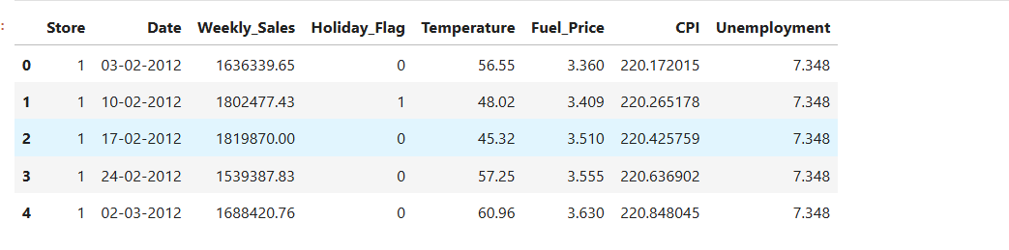

* data.tail()

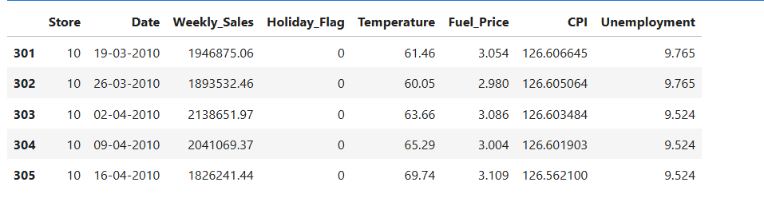

* data.shape

(306, 8)

* data.info()

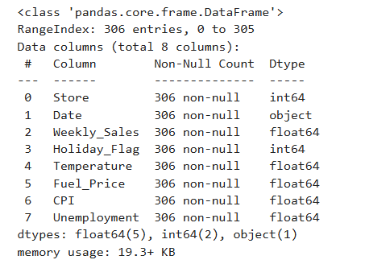

* data.describe()

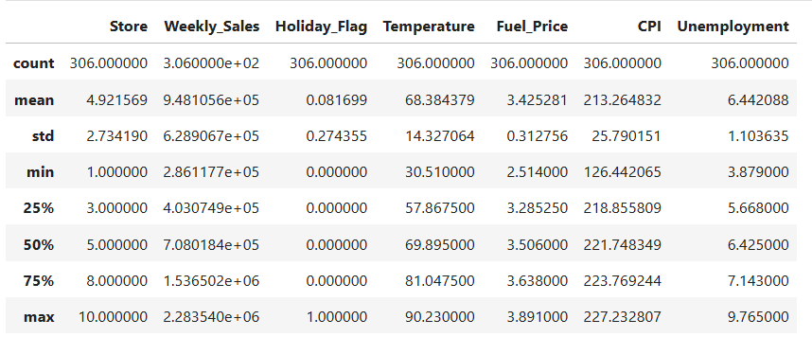

* Data Cleaning

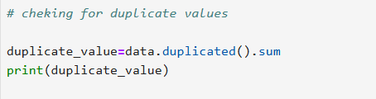

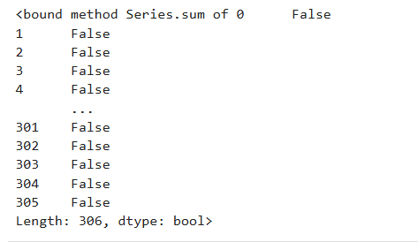

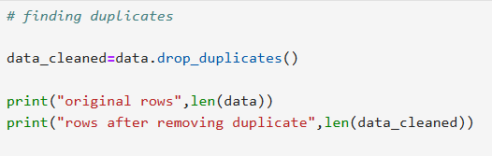



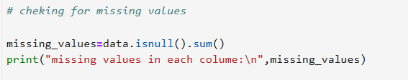

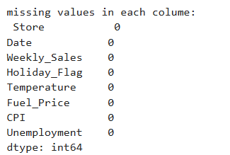

* Data visualization

1. Histogram of **Fuel Price for Store 2**.

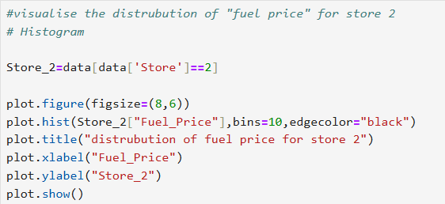

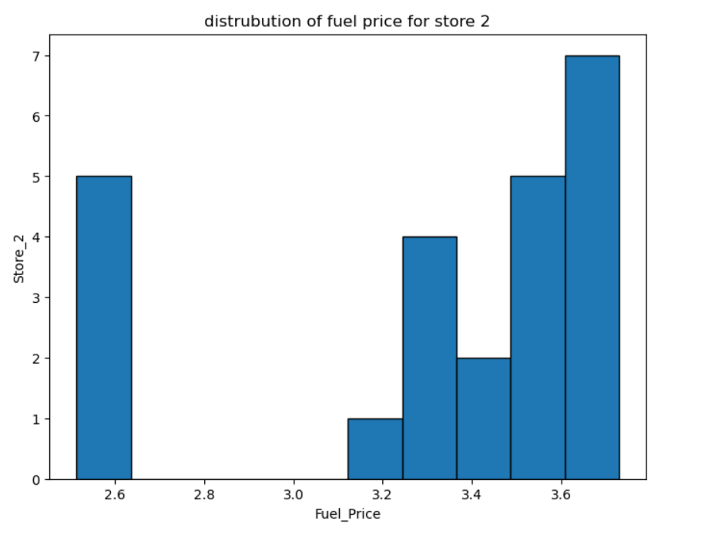

* **Insight:**
* Fuel prices fluctuate within a specific range, showing **a normal distribution**.
* No strong correlation is observed between fuel price changes and sales performance.
* Even when fuel prices are high or low, sales **do not exhibit drastic changes**.

1. Box plot of **Weekly Sales on Holidays vs. Non-Holidays.**

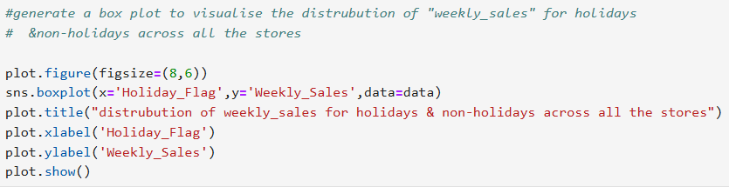

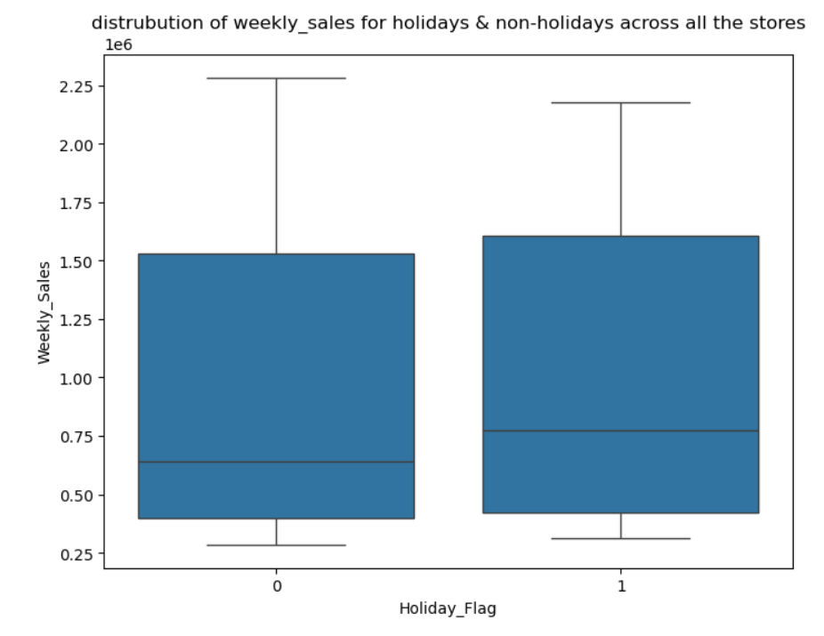

* **Insight:**
* Weekly sales during **holiday weeks** tend to be **higher** than non-holiday weeks.
* Some stores experience **significant spikes** in sales during holidays, indicating increased customer demand.
* However, the **variation in sales** is higher during holidays, suggesting that sales performance may depend on other factors like promotions and store location.

1. Scatter plot of **Temperature vs. Weekly Sales (Store 1).**

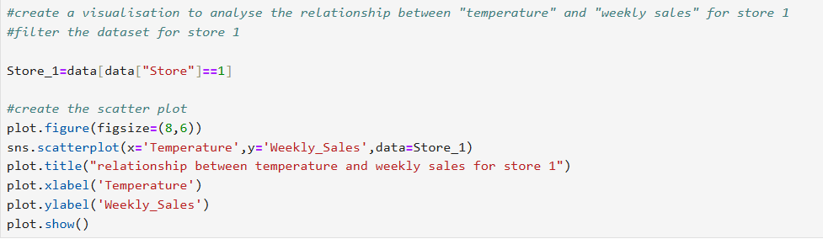

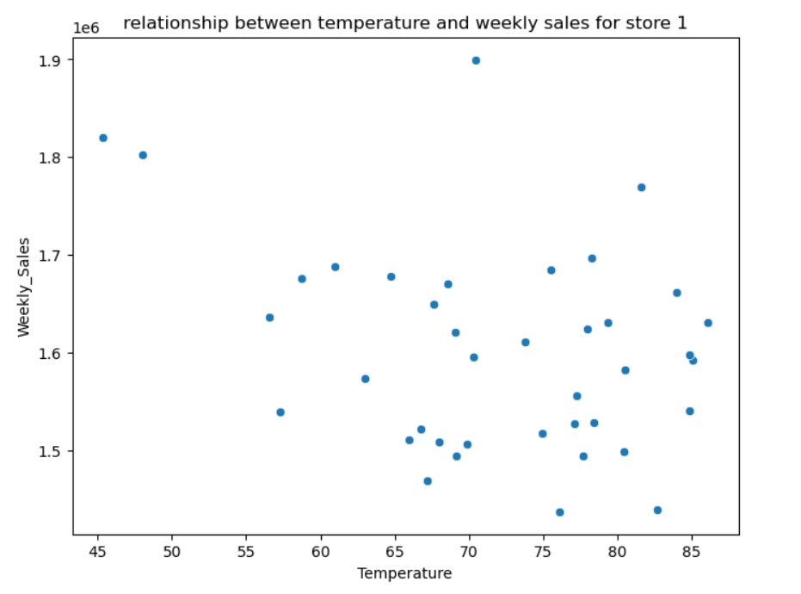

* **Insight**:
* The scatter plot does not show a strong correlation between **temperature** and **weekly sales**.
* While slight variations in sales occur with temperature changes, **no consistent pattern** is observed.
* This suggests that external weather conditions may not be a primary driver of sales fluctuations.

1. Line plot of **CPI trend over time (Store 3).**

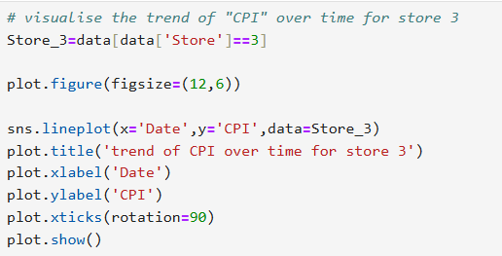

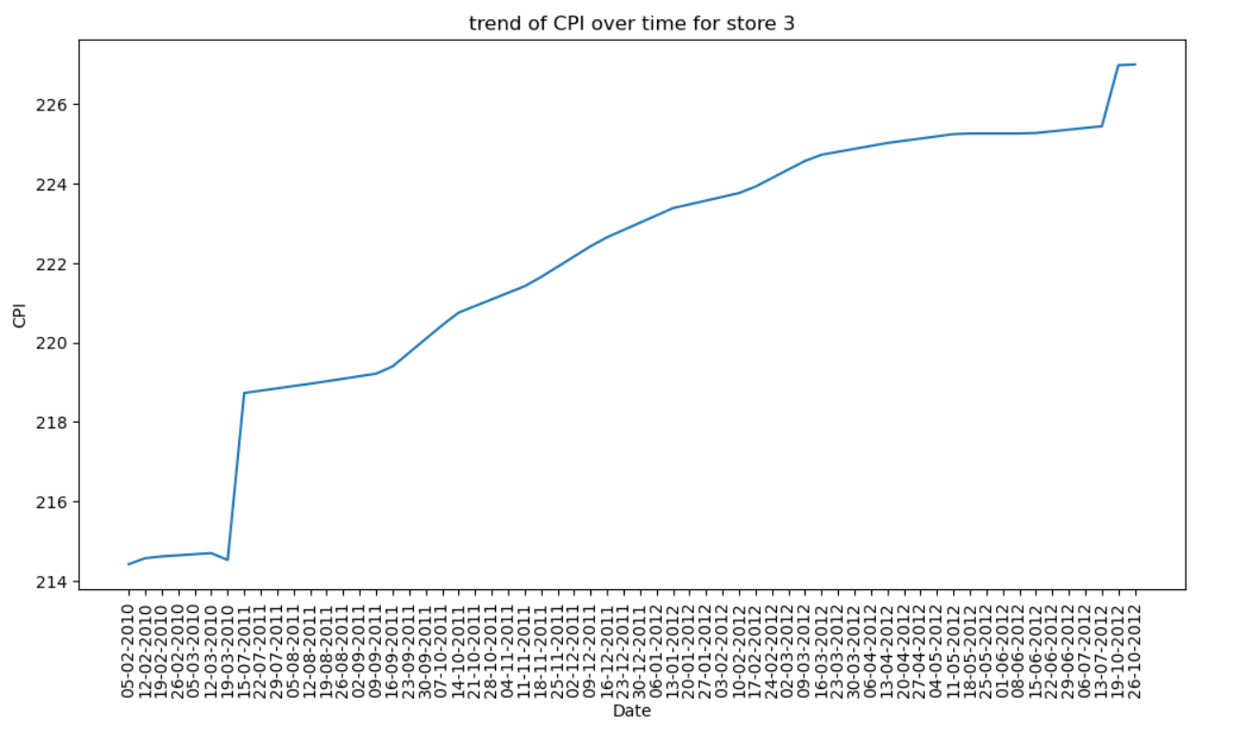

* **Insight**:
* The **CPI has been increasing** over time, indicating inflation.
* However, **weekly sales have remained stable**, suggesting that customers continue to shop despite rising inflation.
* A closer look at product-level data may reveal if customers are shifting to lower-cost items.

1. Bar plot of **Total Weekly Sales by Store.**

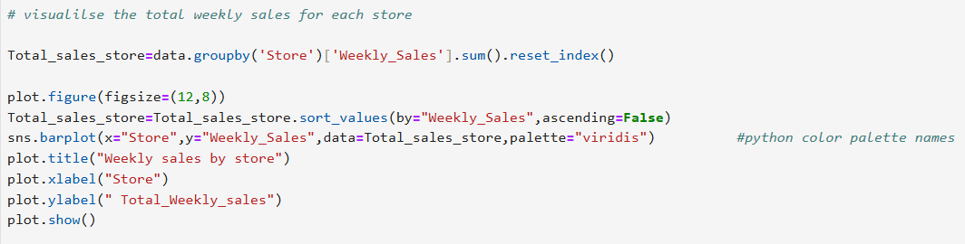

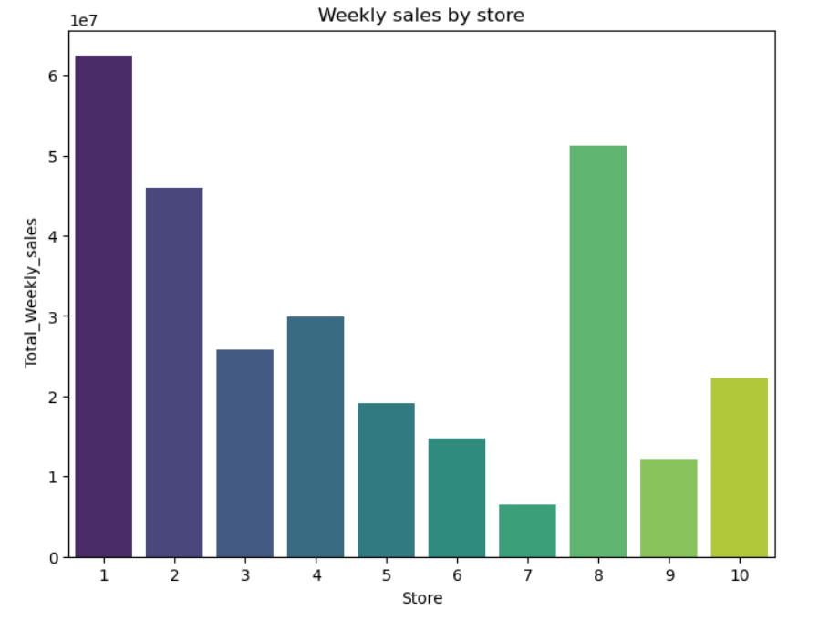

* **Insight:**
* Some stores **significantly outperform** others in total sales.
* The highest-performing stores have **almost double the sales** compared to the lower-performing stores.
* Factors influencing store performance may include **location, population density, customer demographics, and local economic conditions**.
* WhatsApp link:

<https://t.ly/xdmUc>

* LinkedIn link:

<https://www.linkedin.com/in/yuvaraj-shivamurti-13929228b?lipi=urn%3Ali%3Apage%3Ad_flagship3_profile_view_base_contact_details%3B5AmZ0FEZRLedpoaOwux5xA%3D%3D>

* GitHub link:

<https://github.com/Yuvaraj-123-shivamurti>